20. Test of Non-random Distributions

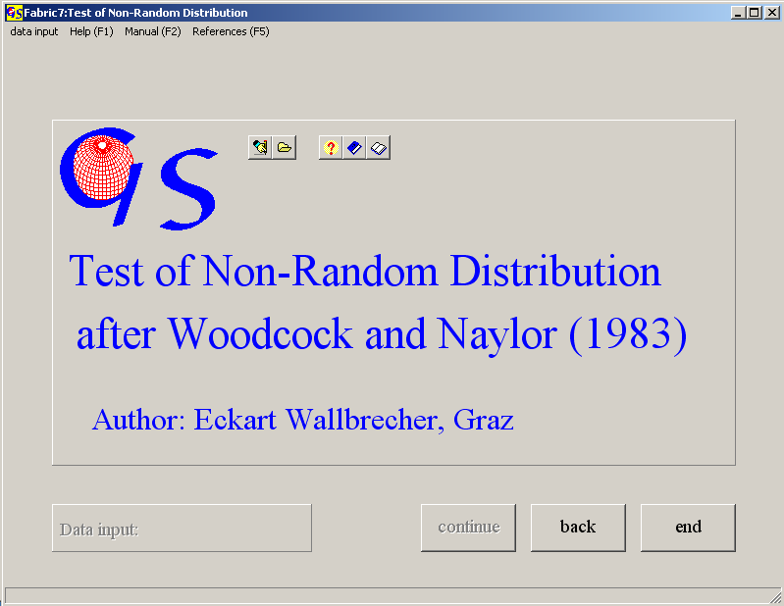
Fig. 1

This program separates significant from random distributions of orientation data. The data input is the same as in the programs 18 and 19.

Fig. 2 shows the graphic form. The three curves mark the border between a field of random distributions and a field of statistically significant ones. The percent-numbers indicate three different confidence levels. The diagramm is only valid for spherical normal (Fisher-) distributions.
The curves are taken from WOODCOCK & NAYLOR (1983).
In the menu "Numbering" you can decide whether the points will show numbers or not.
The options of the menu "Diagram" are explained in program 3.
With the menu "Other methods" you can jump to programs 18 or 19 (Woodcock or Vollmer diagram).
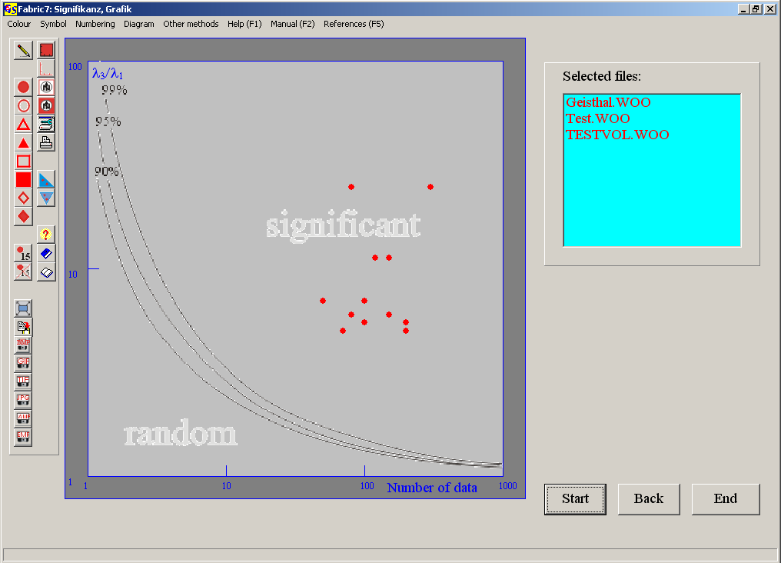
Fig. 2

